**Name:** Siddhi Nandaniya

**Project**

**Whoohoo Game**

**Date: 19/10/2020 Monday Time: 1:00 PM**

As soon as I got this assignment, I read all the specifications and requirements 5-6 times for better understanding of the game. first, I tried to understand the game using pen and paper & played it in my mind, imagined how it would look like when I finish making it. At First, I was blur, couldn’t get any idea about putting controls on the form. There are many questions arising while putting controls on the form. I started with the folder name which is same as the mentioned in assignment requirement. after that, first thing that I needed to do is “roll the 3 dice”. I found the pictures of the dice on the website using google and used it in my assignment.

**Time**: 2:00 pm

**Date**: 19th October

**How Long:** 1-2 hours

**Questions that arise:**

How will I roll the 3 dice without having long code for single dice alone? Should I use For loop or not? how will I work on animation while player roll the dice? where should I display the number of the rolling dice? should use images of the dice or only numbers that displays?

**Difficulties:**

1. roll the three dice at the same time with animation.

**How I Overcame:**

I have tried for loop for the dice rolling & animation. It worked after trying again & again. I have learned in the lecture about for loop. I have found dice images from the website. I have used picturebox with the images of dice. First I placed 3 picturebox on the form. I have given informative name to it then I have added images of dice that I have found. later I have only used for loop for dice rolling. it was working for the dice rolling then I have tried again for loop for animation with rolls the dice 10 times faster. I have also used Random r = new Random(); to get a random 6 values on the

int dicevalue = r.Next(1, 6);

dice. I have also used Dice array of length 3. you can see the picture below that I have done in the program.

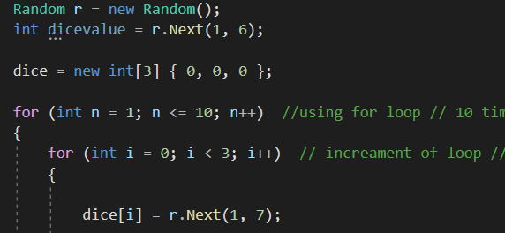

I have done a bit research to get these dice pictures.

==================================================

// Reference P1: Externally Dice Images

// Purpose: Dice Images to show the dices in the game

// Date: 19 October

// Source: Online Website from google /

https://www.flaticon.com/free-icon/die-face_165?term=dice&page=1&position=14// Assistance: from online website, this help to get pictures of dice to use in the game Whoohoo.

===================================================

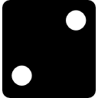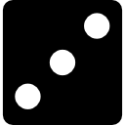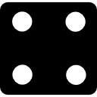

===================================================

// End reference p1

==================================================

**Lessons that I learnt:**

I have learned how to roll the 3 dice at the same time with animation.

**Time:**

**Date:**

**How Long:** 7-8 Hours

**Questions that arise:**

How Will I put all the controls on the form for single player, Double player & Player Vs Program? How will I set all these control on the form so player doesn’t have to find all over the form and understand the game properly without giving instructions about what to do next?

**Difficulties:**

I have not had any major difficulties in setting the controls and naming it except where to set all these?

**How I Overcame:**

I have tried at least for 1 hour to get over this. first, I have made group box for single player (**picture 2**) and the I have made group box for double player (**picture 3**). both boxes were big enough. so I have decided that when single player is playing the game the other group box should be disabled and hidden from the player So I have made another small group box (**picture 1**) So, player can choose how they would like to play and other controls can be stay hidden from them. I have also made another group box for the hold dice & Roll Dice Button. I have not had any idea how to hold the dice but I started with putting controls for it on the form. **(picture 4**). I have decided to have same group box for the Player VS Program So when A player chooses to play with program same group box (**picture 3.1**) would be shown up but with major changes in it (e.g.) player 2 Name: Computer

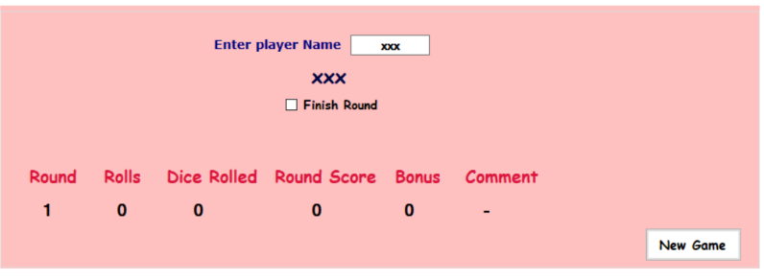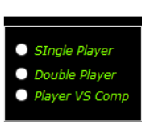

1. **(2)**

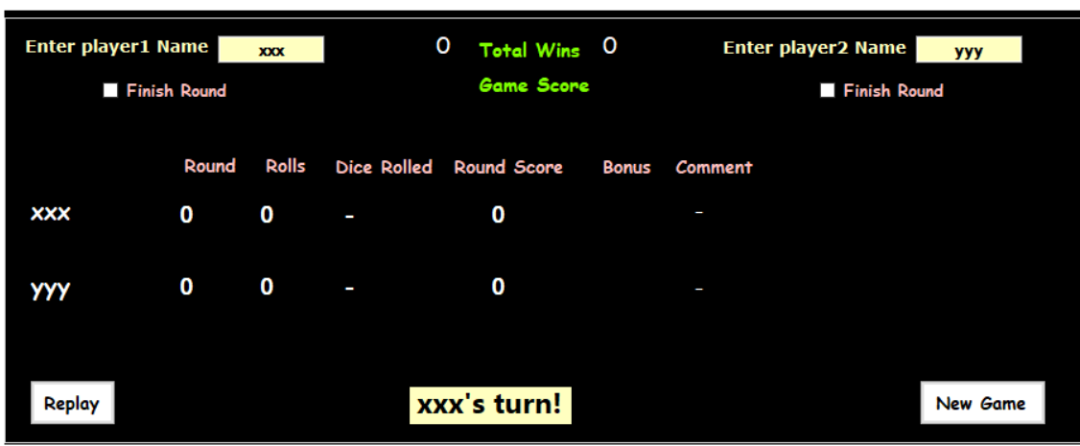

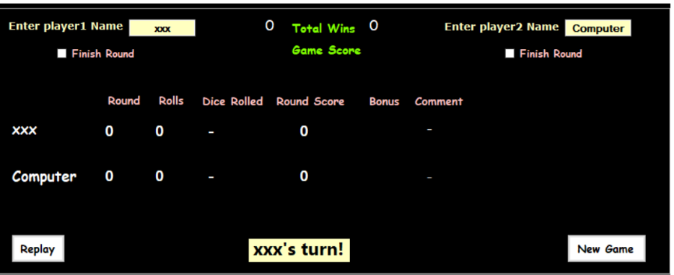 **(3)**

**(3.1)**

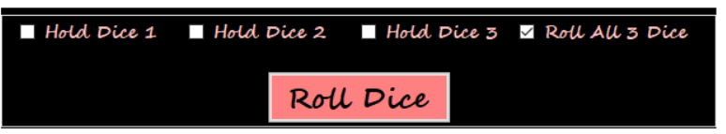

**(4)**

**Lessons that I learnt:**

Here, I took so much time set all these controls as I have not had any idea how it will work as a player when he or she will play the game. I have learned a lot about setting all the controls properly on the form.

**Time:**

**Date:**

**How Long:**

**Questions that arise:**

How will I display round number & rolls (count) for Single Player? and & the dice will be held whenever player wants to? How will I get bonus score for the turn when it is sequence in a row of dice? How will I get the end score (final score at the end of the game)? How Will I post comments as player chooses to roll the number of dices and get bonus score?

**Difficulties:**

I have had difficulties displaying bonus score. the bonus score is counted to the game score (final score) but it couldn’t displayed as there was some mistake but after trying 2-3 hours I couldn’t make it. So, bonus score doesn’t display but it is added to the game score (final score). Another difficulty faced is getting bonus score for sequence numbers in a dice row. that is really difficult task for me to do still have wrote some coding for it but it is not working.

**How I Overcame:**

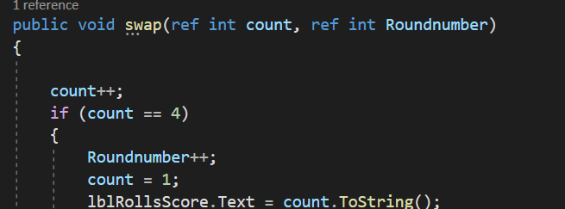I have created new method for the called swap (for rolls) & comment. & I have initialized roundnumber at the beginning of the code.

Swap method for Rolls



**(declaration & Initialization)**

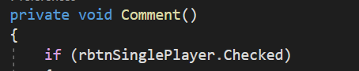

**(comment method)**

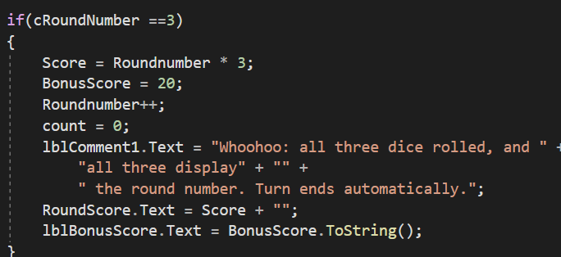 I have tried coding using (for loop) for bonus score that can display when it really counts but it doesn’t display but it added to the end game score. I didn’t get it work after trying so hard. you can see the picture below.

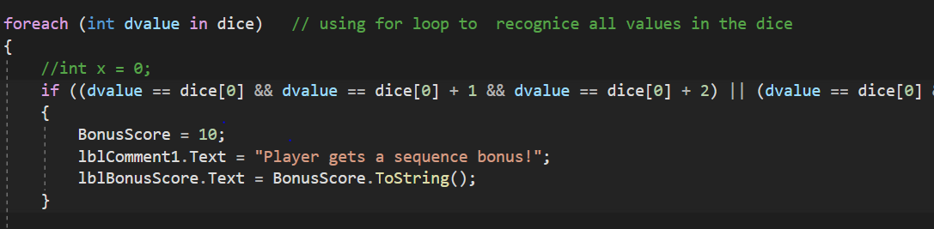For holding dice, I have used 3 checkboxes. you can see picture below.

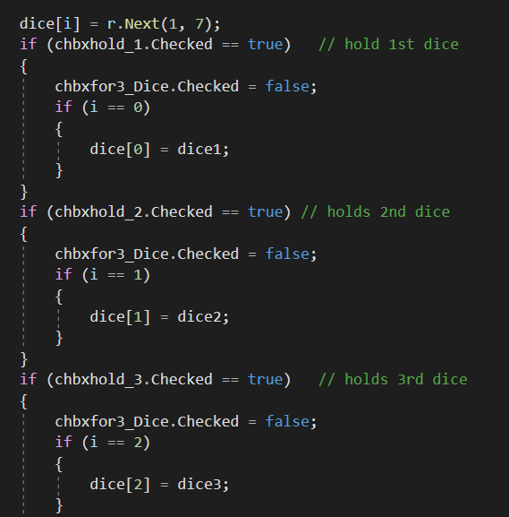

The finish round checkbox is not working for both players, so the round score only will be counted at the roll number 3. it counts sum of the round score at the end of the game.

**Lessons that I learnt:**

I have learned to roll the three dice with animation which displays the score for the single player with specific game rules.

**Time:**

**Date:**

**How Long:**  3-4 hours

**Questions that arise:**

How will be the turn changes automatically for two player and scores and all others specifications will be displayed at two player’s place? how will I displays the name of the players and get to know whose turn it is?

**Difficulties:**

To changes the turn automatically for double player & how many times a player wins a game. & names of the players displays when a player taking it’s turn.

**How I Overcame:**

I have set two texboxes and label for two different players so different player can type their names in respective text boxes and that names will be displayed in a label called instructions ( whose turn it is). for turn changes, I have declared Boolean checkchange (you can see picture below)



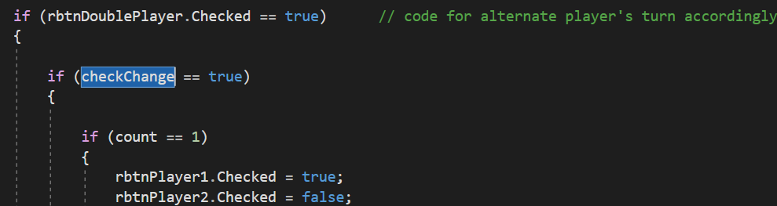

The coding that displays in the picture works for the turn changes. I have set radio button in one group box for the players which changes automatically using Boolean checkchange. & when radiobutton chages the name of the player will be displayed in label like this “player 1’s turn!” the name of the player 1 will be taken from the text box which is typed the users. You can see the picture below.

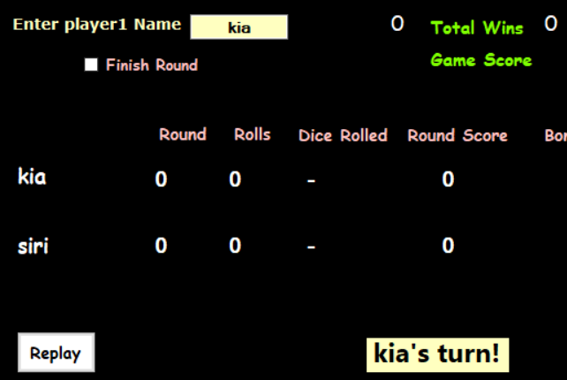

for winning numbers, I have compared last two final score of the two players. whoever will get more score the win number will be increased by 1 and will be displayed.

**Lessons that I learnt:**

The main & important thing I have learned is to change turns of the players automatically. I have set the radio button so whenever player 1 is playing the game everything (round score, rolls, game score) displays for the player1’s.

**Time:**

**Date:**

**How Long:** 5-6 hours

**Questions that arise:**

How will I let program take it’s turn automatically 3 times without clicking on roll dice button? how the hold dice thing will work in the scenario?

**Difficulties:**

I have had difficulties getting round score and bonus score for the program and player.

**How I Overcame:**

after trying for 3-4 hours I couldn’t get round score to the final score properly. I have set radio button for the program and player in a group box then used same code as I used for double players only exception is when program will take it’s turn the dice will automatically roll 3 times it doesn’t hold the dice and the round score will be counted at the roll of 3. before program takes its turn, it holds for the 1 second then all 3 dice roll again it holds for 1 second then it rolls. I have used System.Threading.Thread.Sleep(1000); for a short break between three rolls.

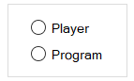

(radio buttons for program & player) which will be hidden while playing the game.

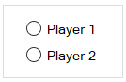

I have used 2 radio buttons to alternate players turn automatically.

**Lessons that I learnt:**

I have learned how a program and a player can play with each other & how program takes its turn without clicking any button by the user.

**Time:**

**Date:**

**How Long: 1 hour**

**Questions that arise:**

**how will I make players play game again? should I give option to so a player can start a new game?**

**How I Overcame:**

I have set 2 buttons one is replay & second is new game button for the players so they can start a new game whenever they want, or they can replay it after finishing one game. you can see the picture below.

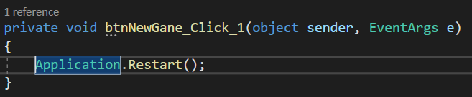

**Lessons that I learnt:**

I have learned how to restart a game and reopen the application.

**\*\*\*\*\*\*\*\*\*\*\*\*\*\*==============================\*\*\*\*\*\*\*\*\*\*\*\*\*\*\***